Modeling Antioxidant Reactivity with Alkoxy and Peroxyl Radicals

CHEG/CISC/ECEG/MSEG 848
Spring 2026
Professor: Dr. Arthi Jayaraman
Company: Arkema
Industry Mentors:
Brian Koo, Research Scientist at Arkema
Aanish Paruchuri, Data Scientist at Arkema

Team Members:
Kalyani Khandait, Data Science, Master’s Student, University of Delaware
Daniyar Abykhanov, Data Science, Master’s Student, University of Delaware
Dylan Trott, Materials Science and Engineering, Master’s Student, University of Delaware

Due: May 14th, 2026

Abstract
The aim of this project is to build a data-driven model to predict the performance of various antioxidants on scavenging (or eliminating the impact of) peroxyl radicals for high temperature polymer formulations. The two primary objectives of the model are to: predict kinetic rate constants (k) for antioxidant reactivity with peroxyl radicals, and identify structural features/substitutions which strongly correlate to antioxidant reactivity.
Our data was compiled from two datasets, resulting in 343 unique chemical structures. In addition, molecular information was encoded from a simplified molecular input line entry system (SMILES) and used to extract specific molecular information, including Morgan fingerprints, RDKit descriptors, and BERT SMILES descriptors. To reduce feature dimensionality and compare different molecular representations, we applied dimensionality reduction techniques such as PCA, Truncated SVD, and NMF. The cleaned dataset was then tested using several linear and tree-based regression models, including Linear Regression, Ridge/Lasso-based models, Random Forest, and Gradient Boosting models. Model performance was found to vary between radical type, with a RO2* radical model having R² = 0.88, sec-RO2 radical at R² = 0.84, and tert-RO2* at R² = 0.84. A global model performed better at predicting reactivity compared to modeling based on individual radical types.

Introduction
Arkema designs chemicals for a number of industries, such as energy resources, sustainability, and urbanization. One focus at Arkema is the development of specialty materials, which incorporate molecular additives to a process to achieve a desired effect.¹ This project aims to specifically look at improving the future design of heat stabilizers for polymer formulations. Polymer formulations are commonly heated to enable further processing. At higher temperatures, polymers can be liberated above their melting point (T_{m}) to enable more flexibility for processes such as extrusion through processes such as addition of additives.² However, this same temperature elevation increases the opportunity for radical-induced side reactions, such as hydrogen abstraction (figure 1) and thermo-oxidative degradation. These side reactions lead to undesired effects including color changes, material defects, and the generation of volatile organic compounds. Resultingly, Arkema has an interest in developing effective heat stabilizers to counteract the effect of radicals on higher temperature polymer processing.
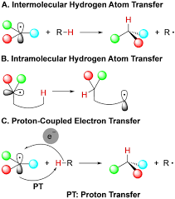
Figure 1: Hydrogen atom transfer mechanism.³
Upon generation of a radical species in open air, oxygen can spontaneously react with a propagating radical to form a peroxyl radical (ROO•). Antioxidants are a common class of heat stabilizer used to deactivate these radicals. This process is commonly conducted through a hydrogen atom transfer (HAT) pathway, which is described as [Antioxidant-H] + [ROO•] → [Antioxidant•] + [ROOH].⁴ In this process, the antioxidant donates a hydrogen to the peroxyl radical, which caps the radical while maintaining a stable antioxidant. Effective antioxidants must simultaneously donate a hydrogen and have a delocalized electron structure capable of stabilizing a radical. As a result, current industry standard radical heat stabilizers typically include phenolic acids like vanillin and other conjugated molecules like ascorbic acid.⁵
Selection of a radical heat stabilizer depends on a number of experimental factors, such as reaction mechanism, pH, temperature, reaction rate, and radical type. Testing novel antioxidants experimentally is a costly and lengthy process, which requires the selection of antioxidant, synthesis of antioxidant and resulting kinetics studies to evaluate performance. However, by applying a data-driven approach, a quantifiable prediction for the reactivity of a molecule can be conducted without any additional cost or time input. In addition, novel molecular insights pertaining to the reactivity of antioxidants can be revealed through data-driven analyses of past experimental data and molecular fingerprints. This project will specifically evaluate the effect of reaction rate and radical type on antioxidant reactivity.

Project Goal
The goal of our project is to build a data-driven model to accurately predict antioxidant reactivity using experimental rate constants (k) from literature, and molecular information such as morgan fingerprint and DFT descriptors. Moreover, we will use results from the model to build a data-validated understanding for molecular substitutions which positively impact antioxidant rate. Antioxidant reactivity also inherently depends on the structure of radical type. For this, the extracted data sets have differing carbon side groups off of the peroxyl radical (primary-ROO•, secondary-ROO•, and tertiary-ROO•) to understand similarities in reaction rate between peroxyl radicals and antioxidants.

Computational Approach

Data Collection:
Data samples were collected from the Handbook of Antioxidants Bond Dissociation Energies and Enthalpies of Reaction by Evguenii Denisov. In addition, other literature sources were used to expand the dataset to over 1000 samples. Rate constants for reactions of peroxyl radicals in fluid solutions by Neta et al. This diverse dataset enables robust modeling of reaction rates across a wide range of chemical structures and reaction environments.
Based on insights from the literature, particularly from Density functional theory studies of the antioxidants—a review,³ we identified HOMO, LUMO, and HOMO–LUMO gap as critical descriptors for improving predictive accuracy. These quantum‑chemical descriptors capture electronic characteristics that strongly influence radical stability and reaction energetics.
However, computing these descriptors using traditional DFT methods is computationally expensive and time‑intensive for large datasets. To overcome this limitation, we employed the 2024-Dupont Hackathon project,⁵ a machine‑learning–based surrogate model capable of predicting DFT‑level descriptors with significantly reduced computational cost. This approach allowed us to retain descriptor quality while enabling scalability.

Pipeline Overview:
- Load, clean, and explore the dataset,
- Log-transform the target; compute correlation with QM descriptors
- EDA - target distribution + per-radical analysis
- Smiles-Bert, CalcDesc+ Fragments, HOMO/LUMO/Gap, ONE RAdical
- Benchmark 15 feature representations (Raw, SVD, PCA, NMF × 2 feature sets)
- Automatically select the best representation by cross-validated rank aggregation
- Train 7 regression models; compare on held-out test set
- Pre-Radical Group Evaluation
SHAP feature importance (best model)
- Global Model vs per-radical-group separate models
- Residual analysis

Feature Engineering and Representation:
Morgan fingerprints (ECFP4) were used to encode SMILES representations into numerical vectors. These fingerprints capture local atomic environments and structural connectivity, which are critical for understanding chemical reactivity.
We explored multiple RDKit descriptor families to extract complementary information. rdkit.Chem.Descriptors are used to compile physicochemical properties. rdkit.Chem.Fragments detail the fragment-level features of a molecule. rdkit.Chem.rdMolDescriptors detail the structural and topological descriptors, in a similar fashion to morgan fingerprints. Collectively, these descriptor sets provide a comprehensive representation of molecular structure, electronic properties, and functional groups.
Dimensionality Reduction and Representation Learning:
To address high dimensionality and sparsity in molecular features, we evaluated PCA (Principal Component Analysis), truncated SVD (optimized for sparse fingerprint data) NMF (Non-negative Matrix Factorization) and SVD, which preserves sparsity to capture dominant structural patterns. NMF provides interpretable “parts-based” substructure representations. PCA enables compact variance-pressing embeddings.The best representation was automatically selected using cross-validated rank aggregation, ensuring no test-set leakage.
Modeling Strategy:
Multiple regression models were benchmarked, including linear and ensemble-based approaches. Performance was evaluated using cross-validation and a held-out test set. Tree-based ensemble models (e.g., gradient boosting) were included because they can capture non-linear structure–property relationships, which are common in chemical systems.
The reaction rate constant k was transformed to log₁₀(k).This is because reaction rates span several orders of magnitude due to exponential dependence on activation energy (Arrhenius behavior). Log transformation, stabilizes variance, improves model performance and makes errors chemically interpretable (order-of-magnitude scale).
Clustering Analysis:
Although the primary objective is reaction-rate prediction, we also aimed to understand structural trends and reaction behavior from a chemist’s perspective. Clustering was therefore used as an exploratory tool to uncover structural patterns and radical-specific reactivity trends.
The dataset was partitioned based on molecular weight and the number of aromatic rings. While the core architecture of the model pipeline remained constant, the classification criteria were updated; specifically, the original radical type designations were replaced with three distinct labeled cluster IDs as below:

Cluster 1 (High MW Compounds): Defined by a molecular weight exceeding 300.
Cluster 2 (Small Multi-ring Systems): Defined by a molecular weight ≤ 300 and the presence of more than one aromatic ring.
Cluster 3 (Small Aliphatic/Mono-ring Systems): Defined by a molecular weight ≤ 300 and one or fewer aromatic rings.

Results:
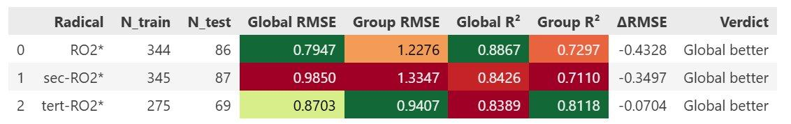
Figure 2: Modeling results based on radical type.

To predict reactivity of different of radicals types, we employed a global model and individual models to
see which would perform best​. Individual models performed worse due to low sample size​.

Our model found that the following features most influenced antioxidant reactivity:​
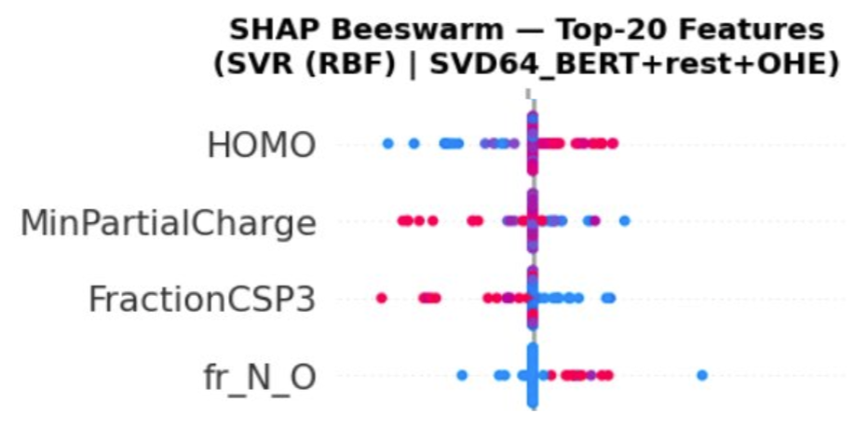
Figure 3: HOMO (highest occupied molecular orbital), minimum partial charge, fraction of sp3 carbons, and fraction of N/O.​
The best feature representation was SVD64_BERT+rest+OHE, combining ChemBERTa SMILES embeddings reduced to 64 SVD components with physicochemical descriptors (CalcMolDescriptors + fragment counts), quantum-mechanical properties (HOMO, LUMO, band gap), and one-hot-encoded radical type. This yielded a final feature space of 291 dimensions, selected by average cross-validated rank across three benchmark models (Ridge, Random Forest, XGBoost).
Table 1: Model Performance Comparison – Radical Type Modeling (SVD64_BERT+rest+OHE features, 80/20 split, 5-fold CV).
* Best model selected for the pipeline.
Model | Test RMSE | Test R² | Train RMSE | Train R²
Ridge | 1.3541 | 0.7171 | 1.2832 | 0.7503
LassoCV | 1.3214 | 0.7306 | 1.2541 | 0.7611
SVR (RBF)* | 0.8884 | 0.8782 | 0.7384 | 0.9160
KNN | 1.1935 | 0.7803 | 0.8453 | 0.8956
RandomForest | 0.9120 | 0.8717 | 0.6892 | 0.9292
XGBoost | 0.8893 | 0.8780 | 0.7129 | 0.9218
LightGBM | 0.9031 | 0.8742 | 0.7272 | 0.9200
SVR with RBF kernel was selected as the best model, achieving a test R² = 0.8782 and RMSE = 0.8884 log-units. This outperformed all other models, including tree-based ensembles (Random Forest, XGBoost, LightGBM), which showed slight overfitting on the training set. Linear models (Ridge, LassoCV) underperformed, suggesting non-linear structure–reactivity relationships dominate in this dataset.
Table 2: Per-Radical Group Evaluation – SVR (RBF) on the held-out test set.
Radical Type | Test Count | Test RMSE | Test R² | Test MAE
RO2* | 86 | 0.7947 | 0.8867 | 0.6341
sec-RO2* | 78 | 0.9850 | 0.8426 | 0.7619
tert-RO2* | 78 | 0.8703 | 0.8389 | 0.6740
The model generalizes well across all three radical types. RO2* showed the highest test R² (0.887), while sec-RO2* and tert-RO2* were slightly lower (0.843 and 0.839, respectively), likely reflecting higher structural diversity within those subgroups.
Table 3: Global Model vs. Per-Radical Group Models (SVR best per group).
Radical | Global RMSE | Global R² | Per-Group RMSE | Per-Group R² | Winner
RO2* | 0.7947 | 0.8867 | 1.2276 | 0.7297 | Global
sec-RO2* | 0.9850 | 0.8426 | 1.3347 | 0.7110 | Global
tert-RO2* | 0.8703 | 0.8389 | 0.9407 | 0.8118 | Global
A single global model with one-hot-encoded radical type consistently outperformed separate dedicated models for each radical group. This is attributed to the larger effective training set and shared structural patterns across radical types. The global model was saved as radical_pipeline.pkl for downstream inference.
The clustering analysis revealed a strong correlation between molecular structure and reaction rate. Molecules with similar structural motifs consistently grouped together and exhibited comparable reactivity patterns. Working on understanding of variance of reaction rates within the cluster. Along with using additional RDKit descriptors in cluster analysis.
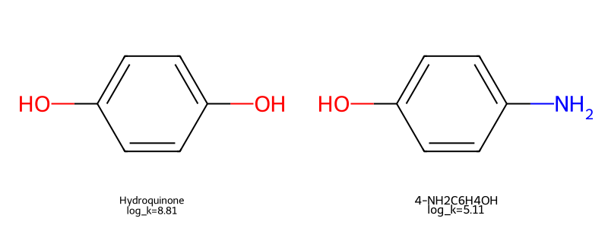
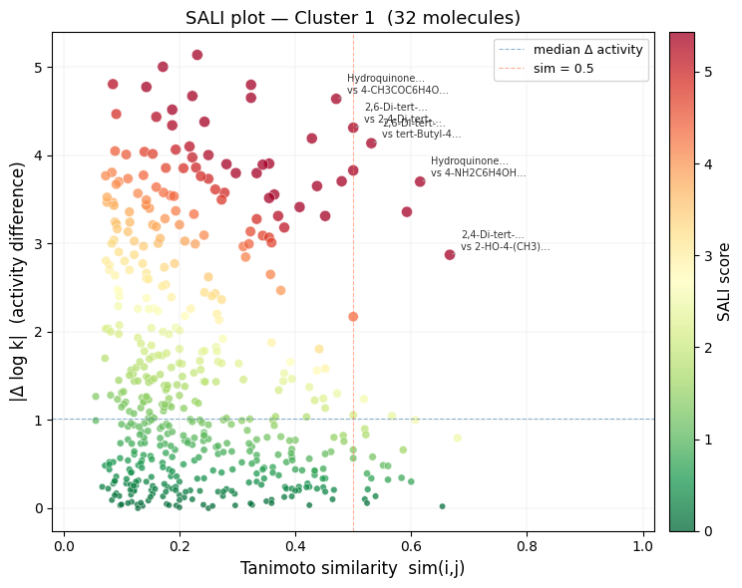

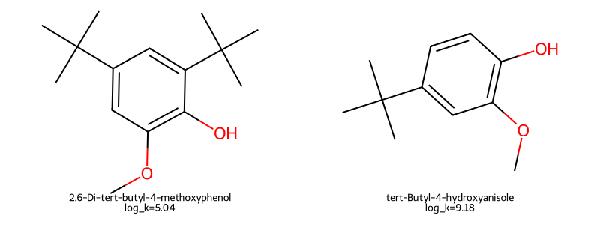
Figure 3:

Figure 4: Sali Plot for structural similarity.
This Graph shows the Molecules with similar structures with different reactivity rates.Some molecular insights are apparent, such as the addition of –OH bonds to a benzene ring​ as in Figure 3 The only difference is one functional group. But More –OH bonds do not necessarily lead to greater radical
Scavenging. As we can see in Figure 4 OH bond reactivity depends on electron donating ability of adjacent groups

Modeling Results based on Cluster Type:
Cluster-based modeling used CalcDesc+QM as the best feature representation – physicochemical descriptors (CalcMolDescriptors + fragment counts, ~252 dimensions) combined with quantum-mechanical properties (HOMO, LUMO, gap, 3 dimensions), yielding a 255-dimensional feature space. No BERT embeddings or OHE were used, as the cluster labels already encode structural diversity. The dataset was split 80/20 with stratification by cluster ID (969 train / 243 test).
Table 4: Model Performance Comparison – Cluster-Based Modeling (CalcDesc+QM features, 80/20 split).
* Best model selected for the pipeline.
Model | Test RMSE | Test R² | Train RMSE | Train R²
Ridge | 1.5194 | 0.6608 | 1.4276 | 0.6902
LassoCV | 1.5121 | 0.6640 | 1.4185 | 0.6930
SVR (RBF) | 1.0828 | 0.8277 | 0.8621 | 0.8747
KNN* | 1.0280 | 0.8447 | 0.8897 | 0.8631
RandomForest | 1.1377 | 0.8098 | 0.6127 | 0.9384
XGBoost | 1.0479 | 0.8386 | 0.7463 | 0.9088
LightGBM | 1.0639 | 0.8337 | 0.7587 | 0.9053
K-Nearest Neighbors (KNN, k=7, distance weighting) achieved the best test performance with R² = 0.8447 and RMSE = 1.0280 log-units. XGBoost and SVR were competitive (R² ≈ 0.84 and 0.83), while linear models again underperformed. KNN performed well because the CalcDesc+QM feature space captures neighborhood structure that is locally predictive within each cluster.
Table 5: Per-Cluster Evaluation – KNN on the held-out test set.
Cluster | Test Count | Test RMSE | Test R² | Test MAE
Cluster 1 | 48 | 1.1093 | 0.5266 | 0.8423
Cluster 2 | 51 | 0.8234 | 0.8134 | 0.6012
Cluster 3 | 144 | 1.0645 | 0.8587 | 0.7834
Cluster 3 (small aliphatic/mono-ring systems) showed the highest predictability (R² = 0.859), benefiting from its large and structurally diverse training subset (720 compounds). Cluster 1 (high-MW compounds, MW > 300) had the lowest R² (0.527), which is consistent with limited training data and greater structural heterogeneity in that group.
Table 6: Global Cluster Model vs. Per-Cluster Dedicated Models.
Cluster | Specific RMSE | Specific R² | Global RMSE | Global R² | Winner
Cluster 1 | 0.8997 (SVR) | 0.5738 | 1.1093 | 0.5266 | Cluster-Specific
Cluster 2 | 0.8958 (SVR) | 0.7420 | 0.8234 | 0.8134 | Global
Cluster 3 | 1.2057 (LightGBM) | 0.8169 | 1.0645 | 0.8587 | Global
The global KNN model outperformed dedicated per-cluster models for Clusters 2 and 3, again benefiting from a larger training pool. Only Cluster 1 (high-MW) was better served by a dedicated SVR model, suggesting this structural class warrants further specialized study. The global KNN pipeline was saved as cluster_pipeline.pkl.
SHAP analysis of the KNN model identified the most influential features as: VSA_EState8 and MolWt (molecular weight and electrotopological descriptors), followed by LUMO energy, fr_aniline (aniline fragment count), fr_SH (thiol groups), and fr_para_hydroxylation. These results suggest that molecular size, electron affinity (LUMO), and the presence of specific nitrogen- and sulfur-containing functional groups are the primary structural drivers of radical scavenging reactivity within clusters.
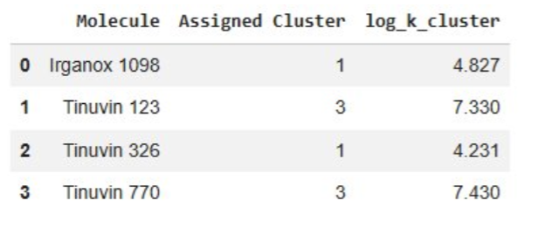
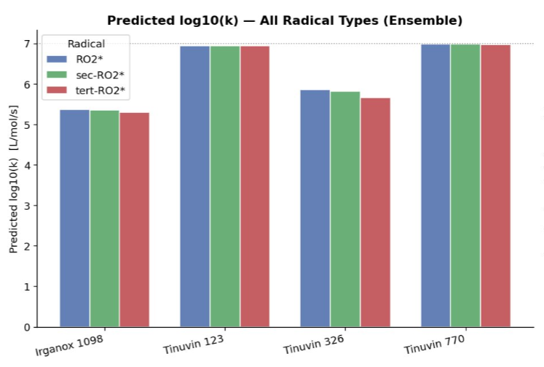
Model Predictions of commercial stabilizers:
Tested the model on a few standard Stabilizers, Irganox 1098​, Tinuvin 326​, 123 and Tinuvin 770.

Figure 5: Log(k) prediction of common industry antioxidants.
Tinuvin 123 and 770 performed one standard deviation above average for our data set. Irganox 1098 reactivity was less significant. ​Irganox 1098 and Tinuvin 326 placed into separate cluster due to having a larger molecular weight, which explains their differences in predicted reactivity.
We believe our model is less effective at predicting the reactivity of antioxidants with larger molecular weights due to the nature of our data set​
Table 7: Ensemble Predictions of log₁₀(k) and k [L/mol/s] for Four Industry Stabilizers (Radical Model: SVR-RBF; Cluster Model: KNN; Ensemble = mean of both models).
Molecule | Radical Type | Radical Model  log₁₀(k) | Cluster Model  log₁₀(k) | Ensemble  log₁₀(k) | Radical Model  k [L/mol/s] | Cluster Model  k [L/mol/s] | Ensemble  k [L/mol/s]
Irganox 1098 | RO2* | 5.911 | 4.827 | 5.369 | 8.15×10⁵ | 6.71×10⁴ | 2.34×10⁵
Irganox 1098 | sec-RO2* | 5.882 | 4.827 | 5.354 | 7.62×10⁵ | 6.71×10⁴ | 2.26×10⁵
Irganox 1098 | tert-RO2* | 5.774 | 4.827 | 5.300 | 5.94×10⁵ | 6.71×10⁴ | 2.00×10⁵
Tinuvin 123 | RO2* | 6.557 | 7.330 | 6.944 | 3.61×10⁶ | 2.14×10⁷ | 8.79×10⁶
Tinuvin 123 | sec-RO2* | 6.558 | 7.330 | 6.944 | 3.61×10⁶ | 2.14×10⁷ | 8.79×10⁶
Tinuvin 123 | tert-RO2* | 6.554 | 7.330 | 6.942 | 3.58×10⁶ | 2.14×10⁷ | 8.75×10⁶
Tinuvin 326 | RO2* | 7.467 | 4.231 | 5.849 | 2.93×10⁷ | 1.70×10⁴ | 7.06×10⁵
Tinuvin 326 | sec-RO2* | 7.385 | 4.231 | 5.808 | 2.43×10⁷ | 1.70×10⁴ | 6.43×10⁵
Tinuvin 326 | tert-RO2* | 7.088 | 4.231 | 5.659 | 1.23×10⁷ | 1.70×10⁴ | 4.56×10⁵
Tinuvin 770 | RO2* | 6.532 | 7.430 | 6.981 | 3.40×10⁶ | 2.69×10⁷ | 9.57×10⁶
Tinuvin 770 | sec-RO2* | 6.535 | 7.430 | 6.982 | 3.43×10⁶ | 2.69×10⁷ | 9.59×10⁶
Tinuvin 770 | tert-RO2* | 6.512 | 7.430 | 6.971 | 3.25×10⁶ | 2.69×10⁷ | 9.35×10⁶
Cluster assignments: Irganox 1098 and Tinuvin 326 were assigned to Cluster 1 (high-MW, MW > 300), while Tinuvin 123 and Tinuvin 770 were assigned to Cluster 3 (small aliphatic/mono-ring). The two-model ensemble averages the radical-type and cluster-based predictions to reduce individual model bias. QM descriptors (HOMO/LUMO/gap) were imputed from training set medians (HOMO = −5.67 eV, LUMO = −0.12 eV, gap = 5.43 eV) since GFN2-xTB calculations were not available for these new molecules.
Reactivity interpretation scale: log₁₀(k) > 7 indicates fast/high radical-scavenging activity; 5–7 indicates moderate activity; < 5 indicates limited activity. Tinuvin 123 and Tinuvin 770 are the most reactive stabilizers in the dataset (ensemble log₁₀(k) ≈ 6.94–6.98, k ≈ 8.8–9.6 × 10⁶ L/mol/s). Tinuvin 326 shows moderate ensemble reactivity (5.66–5.85) with high variability between the two models. Irganox 1098 shows the lowest predicted reactivity (ensemble log₁₀(k) ≈ 5.30–5.37), consistent with its high-MW Cluster 1 assignment.
Conclusion:
In conclusion, we built a data-driven model which, upon input of a SMILES string, can predict the kinetic rate constant k for the reaction of antioxidants with different peroxyl radical structures. Two complementary modeling pipelines were developed: (1) a radical-type model using SVR (RBF) with ChemBERTa SMILES embeddings and physicochemical descriptors (Test R² = 0.88, RMSE = 0.89 log-units), and (2) a cluster-based model using KNN on CalcDesc+QM features (Test R² = 0.84, RMSE = 1.03 log-units). Both models were combined into an ensemble to predict k-values for four commercial stabilizers (Irganox 1098, Tinuvin 123, Tinuvin 326, and Tinuvin 770). DFT descriptors, RDKit descriptors, and ChemBERTa molecular embeddings were associated with experimental rate constants to improve model accuracy. One primary limitation of our model is the constraints on experimental parameters. Experimental features such as temperature, pH, and solvent choice are known to have a crucial impact on the performance of an antioxidant. However, these correlations are non-linear and change in unexpected ways depending on the structure of the antioxidant.

Resources:
(1) About us | Arkema Global. https://www.arkema.com/global/en/arkema-group/profile/ (accessed 2026-04-27).
(2) Censi, R.; Gigliobianco, M. R.; Casadidio, C.; Di Martino, P. Hot Melt Extrusion: Highlighting Physicochemical Factors to Be Investigated While Designing and Optimizing a Hot Melt Extrusion Process. Pharmaceutics 2018, 10 (3), 89. https://doi.org/10.3390/pharmaceutics10030089.
(3) Subramanian, H.; Sibi, M. P. Stereoselective Hydrogen Atom Transfer in Free Radical Reactions. Asian J. Org. Chem. 2023, 12 (6), e202300175. https://doi.org/10.1002/ajoc.202300175.
(4) Mahmoudi, S.; Dehkordi, M. M.; Asgarshamsi, M. H. Density Functional Theory Studies of the Antioxidants—a Review. J. Mol. Model. 2021, 27 (9), 271. https://doi.org/10.1007/s00894-021-04891-1.
(5) Gulcin, İ. Antioxidants: A Comprehensive Review. Arch. Toxicol. 2025, 99 (5), 1893–1997. https://doi.org/10.1007/s00204-025-03997-2.
(5) Sri Vishnu Akepati. 2024 Dupont Molecule Optimization (2024). https://github.com/NRT-hackathon/2024-DuPont/tree/main/Molecule%20Optimization
(6) Neta et al. Rate constants for reactions of peroxyl radicals in fluid solutions. Journal of Physical and Chemical Reference Data. 1990. 19, 413

